Jessica Curley, Guillermo Shick,

Dylan Smith, Jeffrey Winny

Steven Ramsier

February 22, 2019

Team 12 Project A

The internet has a vast influence on the world. We as a team are interested in the power of this influence. Since the world is making this shift, more opportunities are open to internet users, and we have compiled a data set to prove that. What we want to know is, where in the world is the most opportunity. By this we mean where in the world are the most internet users. We intend to prove that societies that have access to the internet have more economic freedom.

By collecting data from … we assembled csv file which were then uploaded to SAS. From here we merged our data into one file. The variables we selected to focus on are internet penetration rate, country, economic freedom index, and GDP per capita. The Internet Penetration Rate determines how many people based on the population use the internet. Because of the size difference, if only population was used, our data would be skewed and inaccurate. Country, kind of self-explanatory, is the location geographically of the data. Economic Freedom Index analyzes the freedom given to individual based on their country. If the county is stricter on their citizens, they may not have the ability to use the internet. GDP per capita looks at the average wealth per citizen. This is also important to analyze because without the economic capacity to provide internet, there is no way to access it, thus the data would ultimately be skewed.

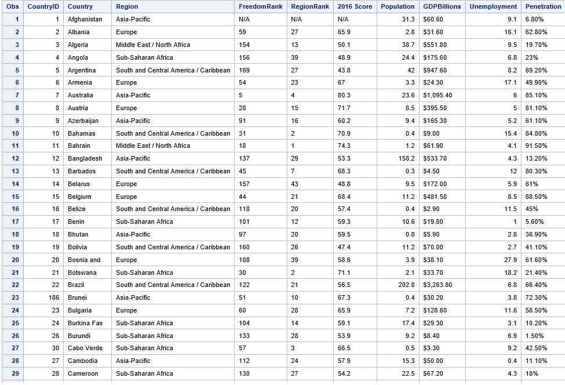

**I certify that the SAS code given is our original and exclusive work**

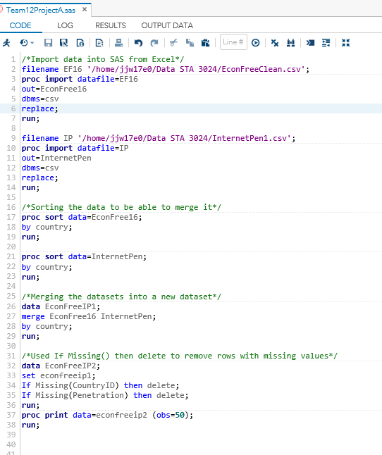

(Proc Print data incomplete set)

Some complications we ran into revolved around a simple proc sort. When first merged, the data had multiple identical variables which, instead of merging properly, duplicated itself. After applying a proc sort, the issue was fixed.

In the future, we will analyze the correlation between economic freedom and geographic location. We hope to find there is a positive correlation between the two variables, country and internet penetration rate. If we find anything that may make our data point stronger, we may add variables. We hope to learn the effect of internet penetration on a region’s economic freedom and GDP.

***We, the project team members, certify that the percentage of the effort listed by each of our names below is an accurate account of the original effort contributed by each team member in the producing of this project and report.***

Name : Percent of Total Work: Statistics Major:

Jeffrey Winny 25% No

Guillermo Shick 25% No

Jessica Curley 25% No

Dylan Smith 25% No